Resistance, resilience, and vulnerability to high-energy storms: A gradient perspective
Organizer: Robert Waide
Co-organizer(s): Evelyn Gaiser and Michael Willig
Overview
Two previous international meetings laid the groundwork for the establishment of an International Hurricane Research Network, with a focus on the Caribbean and Central America. We propose to expand the geographic focus of this nascent network to include scientists from other regions (Asia, Pacific Islands, Australia) where high-energy storms play an important role in structuring ecosystems. Our aim is to establish a self-sustaining multidisciplinary network that will foster comparison among regions and synthesis of understanding about the environmental consequences of high-energy storms. More specifically we will build on a conceptual framework established in previous meetings to advance understanding of how resistance, resilience, and vulnerability of ecosystems to these disturbances vary along environmental gradients such as productivity and biodiversity. We expect to discover complementary studies from other regions and to establish a collaborative mechanism for enhancing the depth and breadth of future research.
Outcomes
Breakout Group Themes
- Concept map to inform a framework – including explicit definition of disturbance terminology; justification for creating a network; network of networks; exploring generalities or patterns in mitigation and adaptation to inform the future; providing information about types of storms and responses to decision-makers
- Gradient approach
  - Spatial – ridge to reef for exploring gradients of resistance, resilience, & vulnerability to disturbance with respect to wind, surge, rainfall
  - Characterizing event type and behavior
  - Damage gradients
  - Linkages across these gradients – connectivity in response (scales of response)
  - Key measurements and metrics of events and impacts – coordinated system of measurements for producing comparable data
- Socioecological framework and feedbacks; socio-political landscape of response; designer ecosystems – human system responses (novel ecosystem trajectories); interactions with disease and disease vectors; long-term evolution in social perception, preparation and response; emergency management; changes in natural resource management and ecosystem service valuation; economic resilience
- Response characterization – Deconstructing how system elements respond to storms – roles of pioneer species responses; trajectories of response; triggers of migration of people and species; invasive species responses; diversity axes; Chapin paper about fast and slow variables (EDPSEEA); above and below ground responses; subsidy-stress models for understanding response
- Multiple disturbance context – press-pulse framework; gradients of storm frequency; legacies of the past; coincident events; projections into the future (probabilistic models of events and impacts); synergisms of events with land-use patterns; predictions based on long-term paleo records (improving models of future probabilities); influence of persistence of climate events (like drought) on response
Results from Breakout Groups
Breakout Group: Multiple disturbances
Group Members: Bob Waide, Steve Davis, Stephen Turton, Qiang Yao, Clark Alexander
Multiple disturbances interact in a feed-forward fashion, with past disturbances (say 1000 years ago) affecting some present state and recent disturbances affecting some future state (say 100 years from now). Over a much shorter window of time (e.g., 1 year), disturbances can interact and even coincide, leading to additive or even synergistic results in affecting the present state.
Focusing on the first increment of this diagram, the current state (plus the ecosystem services that it provides) is a direct outcome of some past history of disturbance, of which we can [perhaps] piece together the frequency, intensity, and sequence of those events. The “stories” that arise from this paleo work can provide a powerful glimpse into the future. [We discussed examples from Florida and Australia.]
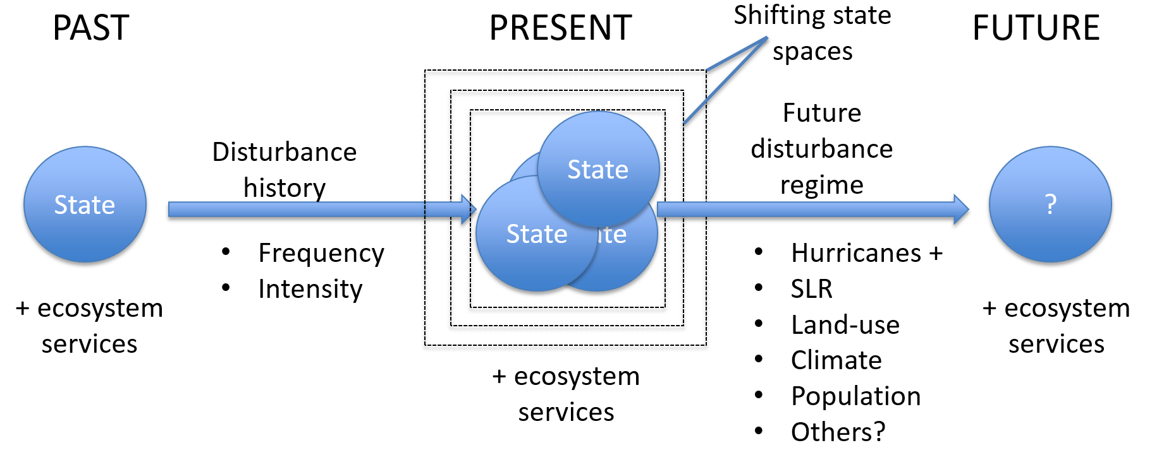
The current state is not static. It is dynamically shifting within some state space that represents its realm of existence—beyond which it would shift to an alternate ecosystem state. This shifting is due to past events (human-caused and natural) whose impacts are still playing out over time, current events that may or may not coincide—all varying in severity and also having a feed-forward effect on the future state and, to some extent, the outcome of future disturbance.
Considering these multiple (past, present, and future) disturbance interactions, we should understand whether the event space in which the system state is dynamically fluctuating in size.
While the future state is unpredictable, based largely on our inability to predict (1) future disturbance frequency, severity, and sequence; (2) future sea level and climate; (3) future land use; and (4) population, we can construct scenarios of future trajectories and states based on what we know about past and present multiple (sequential interacting and coinciding) disturbance events and outcomes.
A final contribution from this group is a recognition of the value in bringing together available tools and datasets to aid us in understanding events that led to the present state as well as the events that contribute to the dynamic shifting of the present state. This will be essential to building scenarios and making predictions about the future.
Breakout Group: Socio Ecology
Group Members: Jeff Onsted, Matthew Duveneck, Brian Wee, Skip Van Bloem, Grizelle Gonzalez, Pallab Mozunder, Nancy Grimm
Main points:
1. We assumed social and ecological systems were coupled a priori.

2. One way to determine resilience would be to use pre-storm condition as a start point and then measure departure from that condition as Euclidean distance back to that point over time. This may be set up two-dimensionally as a social condition and an ecological condition or as two conditions within social or ecological (refer to fig Mike showed in intro on day 1). However, we felt 2 dimensions were better and those would be social, ecological, and a physical component.

3. What needs to be quantified above would be a key question for the RCN to determine.

4. The return to the "pre-storm" condition as a measure of resilience is itself an arbitrary start point because of legacies, etc. However, we have the freedom to set a point/target that we think is best to return to, based on some normative concepts of ecosystem health, equitability in social systems, and stable physical systems. This also helps get around the need to define resilience in non-equilibrium systems.

5. An important goal would also be to define boundary conditions (thresholds) from which recovery is not possible.

Useful conceptual frameworks: figure Mike showed, figure in Duveneck's pub (in press), Peters 2011 figure.

Breakout Group: Response Characterization
Group Members: Christopher Madden, Nicoletta Leonardi, Timothy Schowalter, Barbara Rojas, Sharon A. Cantrell
Summary: We need the RCN to gather available data or to establish new strategies that will help gather data to:
- Study the adaptability of the systems (compared between those that receive frequent storms vs infrequently
- Study the responses depending to the severity of the storms
- Analyze the response depending on the physical characteristics of the gradient
- Compare how the organic and inorganic component respond to the storm
- Compare the presence and absence of pioneers or invasive species.
- Compare drivers vs passenger species
- Study both above and belowground short- and long-termed responses
By doing all of these we should establish parameters that will help us understand how systems are more resilient, resistant or vulnerable to high energy storms.
Breakout Group: Gradient Approach
Members: Jess Zimmerman, Audrey Plotkin, Christine Crenshaw, John Kominoski, Teng-Chiu Liu, Mike Ross, Mike Willig, Loretta Battaglia
Paper by Martin – people are being able to integrate exposure. How can we help people mitigate impacts? Wind exposure is easy to model. Different aspects of disturbance impact different parts along the gradient. What are the susceptible ecosystem services?
Stress-subsidy – subsidy in mangroves but salt impacts all coastal, response may be completely different
Inland – wind and flooding exposure
Reef – waves
Margin between these – coastal very heterogeneous compared to inland
Coastal areas are an ecotone
Remote sensing as a tool to assess degree of exposure/damage – characterizing post-hoc
Gradient of effects that relate back to parts of the landscape – we want to understand those impacts and responses
Intensity attenuation – how often does that happen? Effects of hurricanes are much broader spatially – even inland with intense precipitation. Define the spatial domain and has a footprint. Wind, rain, surge all part of the footprint. Flat landscapes vs mountainous. Storm interacting with the landscape – topographic gradient. Gradient of the storm and gradient in the landscape AND there is landscape heterogeneity (land use, fragmentation) that’s not part of the gradient. Combine rugosity of coastline and inland and how that influences energy dissipation.
Gradients: topographic, human population density, energy
What do you do in prep for a disturbance? Need to know these/quantify
Overarching perspective – Each storm event has a trajectory along which “wind disturbance”, “rain disturbance”, and “surge disturbance” have differing intensities and severities. Moreover, the “spatial context” for these aspects of disturbance intensity and severity are rooted strongly in landscape composition and configuration.
Social resilience and vulnerability may be strongly related to “social subsidies” that relate to the socioeconomic “landscape” within which a site is located (equivalent to species pool effects and connectivity issues).
Intensity of storm – the infrequent intense storm may have more impact than low intensity frequent storms.
Much of the needed information about the geography of storm characteristics may be available, e.g., NOAA. An alternative funding source – products very useful.
Physical topographic gradient – knowledge of impacts, importance of assessment of available tools. Some of these aspects are known but probably not well-integrated. We can do wind, storm surge, but we probably don’t have an integrated framework to assess and characterize all of this.
We are trying to be predictive about the impacts. Where are the most vulnerable locations versus places that are less impacted? More impacted are probably better adapted.
2nd storm had much less impact, less wood there anyway.
Storm prone regions should be biologically better adapted and SE systems too, perhaps. Does that reach a threshold? Warning systems better developed in storm prone areas.
At some point, do pulse events become a press?
Coastal systems are affected frequently by the storm and thus more resistant/resilient. However, human development has diminished ability of natural systems to recover.
Typhoons impact the western US but very infrequently. Huge impacts with flooding, which is both a subsidy and a stress.
Human vs. natural systems. Human systems perhaps less adapted than natural ones and probably lag behind the natural ones in terms of adaptation.
Climate change not explicitly included here but shows up as changes in frequency, intensity, and timing of storms. We don’t include how sea level rise alters the very gradient on which the storm effects play out.
Gradient of storm frequency. We need a network to do this.
- There are lots of tools for characterizing storms but not aware of an integrated global tool for characterizing and predicting responses.
- Storm prone regions should be biologically better adapted and SE systems too because of history. Does that reach a threshold/tipping point? Return intervals are related to susceptibility. Warning systems better developed in storm prone areas.

